CIS 286-Study Guide for Chapters 9, 14

Recursion
What is recursion?
Be able to give an example with details
Any recursive algorithm/method needs a stopping criterion (base case)
Any recursive method can be implemented using iteration
Make sure you know what that statement means
Specifically, what does "iteration" mean?
The iterative method will be faster, though it might be harder to code
If a method calls another method, an activation record is created and pushed onto
the activation stack
This is true for any method, not just a recursive method
Typically, though, more information has to be stored for a recursive method

Recurrence Relations
Know what one is
Be able to convert one to closed form
This means
1. Make a guess at a non-recursive version of the recurrence relation
This usually requires writing out several examples and guessing at the pattern
2. Verify your guess with math induction
Some examples follow
Again, I stress that, for recursion, I need to see these items in your proof
The base step (labeled “Base Step”)
The inductive step (labeled “Inductive Step”)
What is being assumed (Labeled “Assume”)
What is being proven (labeled “Prove”)
Finally, there should be summaries for the base and recursive steps saying
That … and therefore the (base, inductive—choose one) step is proven

1. Convert the recurrence relation to closed form.
t(1) = 2
t(n) = t(n-1) + 3, n > 1
Solution:

Finding the guess:
t(1) = 2
t(2) = t(1) + 3 = 2 + 3 = 5
t(3) = t(2) + 3 = 5 + 3 = 8
t(4) = t(3) + 3 = 8 + 3 = 11
t(5) = t(4) + 3 = 11 + 3 = 14
These go up by 3, so look for multiples of 3. Let me re-list the values, along with multiples of 3.
t(1) = 2 vs. 3 = 3*1
t(2) = 5 vs. 6 = 3*2
t(3) = 8 vs. 9 = 3*3
t(4) = 11 vs. 12 = 3*4
t(5) = 14 vs. 15 = 3*5
So, it would appear that t (n) = 3*n – 1, n ≥ 1. Now, here is a proof by induction that this formula is correct.

Base Step:
The recurrence relation says t(1) = 2.
The formula says t(1) = 3*1 – 1 = 3 – 1 = 2.
So the formula works when n = 1.

Inductive step:
Assume that t (n) = 3*n – 1.
Show that that t (n+1) = 3*(n + 1) – 1, or 3*n +3 -1, which is 3*n + 2.
Proof:
t (n+1) = t(n) + 3, by definition (I called this “reality”)
= 3*n – 1 + 3, by the inductive hypothesis
= 3*n + 2, by algebra,
= 3*(n + 1) – 1, again by algebra. (Actually, I am just copying down what I did initially, but in reverse.)
Here are three more to try.

1. Convert the recurrence relation to closed form.
t(1) = 1
t(n) = t(n-1) + 4, n > 1

2. Convert the recurrence relation to closed form.
t(1) = 1
t(n) = 3*t(n-1), n > 1

3. Convert the recurrence relation to closed form.
t(1) = 2
t(n) = 2*t(n-1), n > 1

Answers (without justification. On the test, you MUST give justification.)
1. t(n) = 1 + 4(n – 1), n > 1

2. t(n) = 3^{(n – 1)}, n > 1

3. t(n) = 2^{n}, n > 1

Mathematical Induction
A technique for verifying a formula based on 0, 1, 2, 3, …
It has two parts
A starting point (Called the base step)
The inductive step
For induction, I won't ask you to define or explain it; I will ask you to use it
There are two ways we have used it
You can use it by itself to verify a formula is true; or
You can use it to verify that a guess at a closed form of a recurrence relation is correct

Steps for math induction:
1. Prove the base step. Label it “Base Step”
2. Prove the inductive step. Label it “Inductive step”. Then:
A.) Write “Assume _____”.
Fill in the blank with the formula for n. Write this assumption down!
B.) Write “Show _____”
Fill in the blank with the same formula, but change n to n+1.
C.) Verify the formula in B. You need to manipulate the formula in B in order to use the formula you wrote for A.
Keep this in mind as you look at the examples. If you omit the phrases Base Step”, “Inductive Step”, “Assume _____”, and/or “Show _____”, you will lose points.
This is emphasized in the comments in red in the examples that follow.
Here is a proof that 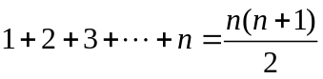, for n=1, 2, 3, … by induction.
Base step: n=1.
The left side is 1
The right side is 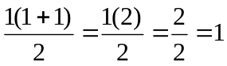.
Since the left side equals the right side, the base case is proven.

You need to have almost exactly what I have in the base step. Specifically,
You need to check the left side of the equation. (This is what I called "reality.")
You also need to check the right side of the equation.
You then need to state that they are equal so that you have proved the base case.

Inductive step:
Assume 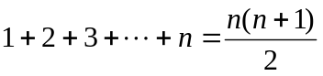.
(This assumption is called the induction hypothesis. It's not so important that
you know its name. I just use the name so I can refer to it later.)
Show that 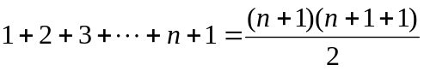.
Note: That fraction simplifies to 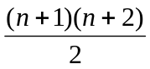
Again, here you need to have the parts that I have above. That is, you need to say,
"Assume …".
You also need to say,
"Show …".

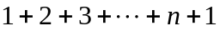
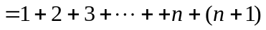 because n is the integer immediately before n+1
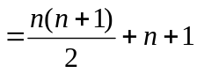 by the inductive hypothesis
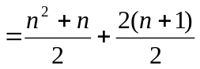 distributing in the fraction and getting a common
denominator
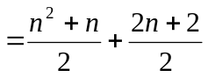 by the inductive hypothesis
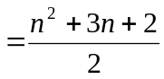 combining the fractions
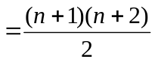 factoring the numerator. This is what we need to
show.
At the end, be sure to summarize with something like, "This is what we need to show."

Example 1: Verify that 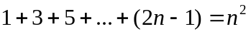, for n=1, 2, 3, …
Proof by mathematical induction.

Base step (n=1)
In class, I called this comparing the actual answer (reality) with the answer predicted by the formula. The left side of the equation is the actual answer. The right side is the predicted answer. Substitute n = 1 into the left side and simplify. This gives . Of course, this is just 1—there is nothing in the middle.
The right side says we should get 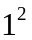, which is 1. Since these two answers are the same, we have verified the formula for n = 1.

Inductive step:
Assume
Show 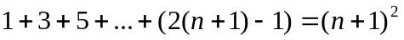. Cleaning up both the left and right sides gives 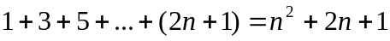. This is what we need to show.
Remember, we need to make 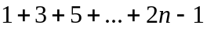 appear in the formula on the left side of the equal sign. This looks like the start of the left side. Let’s continue the left side after this, checking on what we get. The next number after 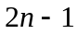 is 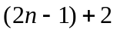, since you add 2 to get from one odd number to the next. Then simplifies to 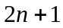. Notice that is the last term in out series. Now we have
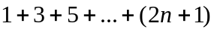
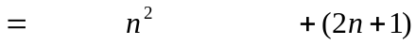, which is exactly what we want. So we have verified the formula.
Example 2: Verify that 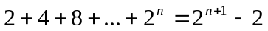, for n=1, 2, 3, …

Base step: n = 1
The left side is 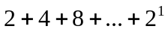. This is just 2. Again, there is no middle.
The right side is 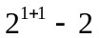, which is 2. Since those two agree, we have verified the formula for n = 1.

Inductive step:
Assume .
Show 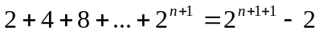. The right side of this is 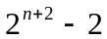.
Notice that the left side of the original equation is 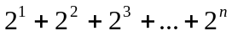.
Here is the process:
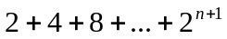
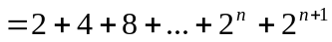
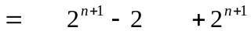
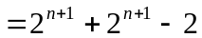
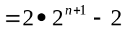
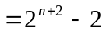, which is what we wanted. We have verified the formula.
Example 3: Verify that 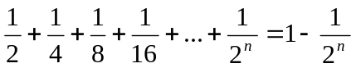, n=1, 2, 3, …
Again, notice that the left side is 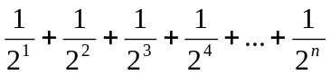

Base step (n = 1)

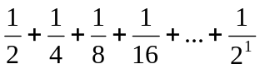 is 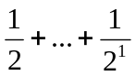, which is really just .
The right side is 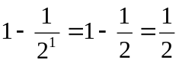. Again, since these agree, we have verified the formula for n = 1.

Inductive step;
Assume:
Show: 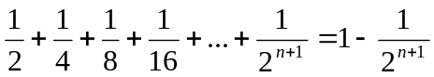
Here is the process.

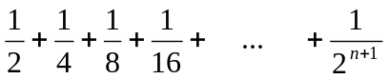
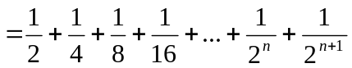
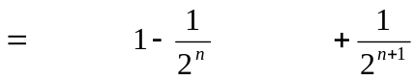
Simplify this.
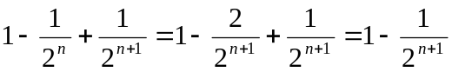. That’s what we needed to show. We verified the formula.

Note: In these examples, I skipped spaces in the formulas. The point of that is to show how one formula relates to the formula that came before.

